- A Naive Bayes classifier is a simple and powerful probabilistic machine learning model based on applying Bayes’ Theorem with a strong (naive) assumption of feature independence.

- It's commonly used for text classification tasks like spam detection, sentiment analysis, and document categorization.

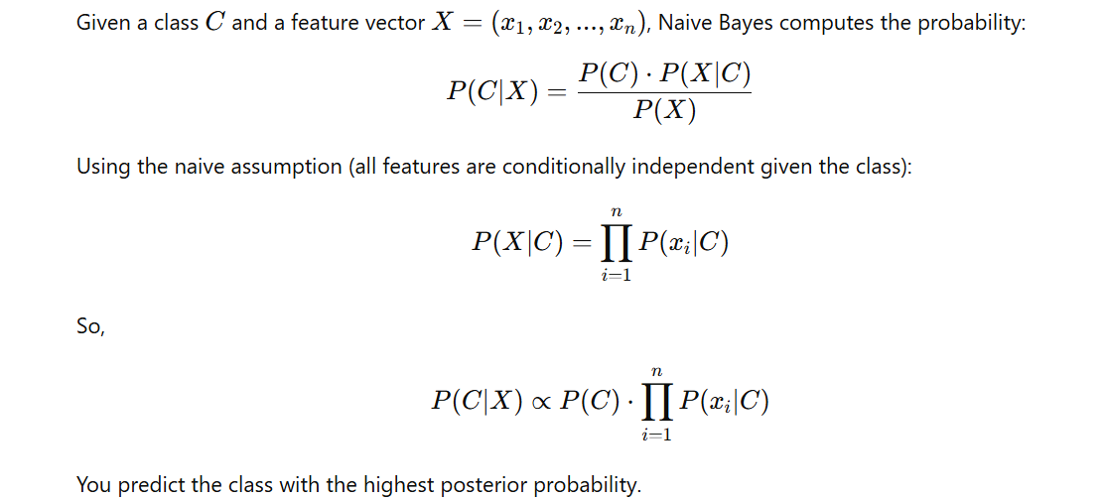

📦 Types of Naive Bayes
- Multinomial Naive Bayes: Best for text data, where features are word counts or frequencies.
- Bernoulli Naive Bayes: Binary features (e.g., word present or not).
- Gaussian Naive Bayes: For continuous features assumed to follow a normal distribution.
Advantages
- Simple, fast implementation
- Works well with high-dimensional data
- Requires less training data than many models
- Performs surprisingly well for text classification
- Handles multiple classes efficiently
Limitations
- Independence assumption often doesn't hold in reality
- Can be outperformed by more sophisticated models
- Struggles with features that never appeared in training
- Not ideal for regression tasks

